Delete a Node from a BST

Deleting a node from a Binary Search Tree takes care. It is easy to find the node, and to delete a node, but then we have to relink the tree so that the BST order is preserved. (Recall that an in-order traversal of BST produces an in-order string.) In the simplest case, we just set a pointer to null. In more complicated cases, we need to locate the node that replaces the deleted node by locating the largest node in the deleted node's left subtree (some algorithms locate the smallest node in the deleted node's right subtree). Most people keep track of two pointers, a parent and a current.
First, find the node to delete. Then identify which of three cases to perform:
(1) If the node is a leaf, just set its parent pointer to null.
(2) If the node has just one child, point the parent to current's child.
(3) If the node has two children, find the node containing the largest item in the node's left subtree and replace the node's object with the largest item. Then revert to case (1) or case (2), with the (just-found) largest item now being the current node.

Find the N in each BST, then delete it properly.

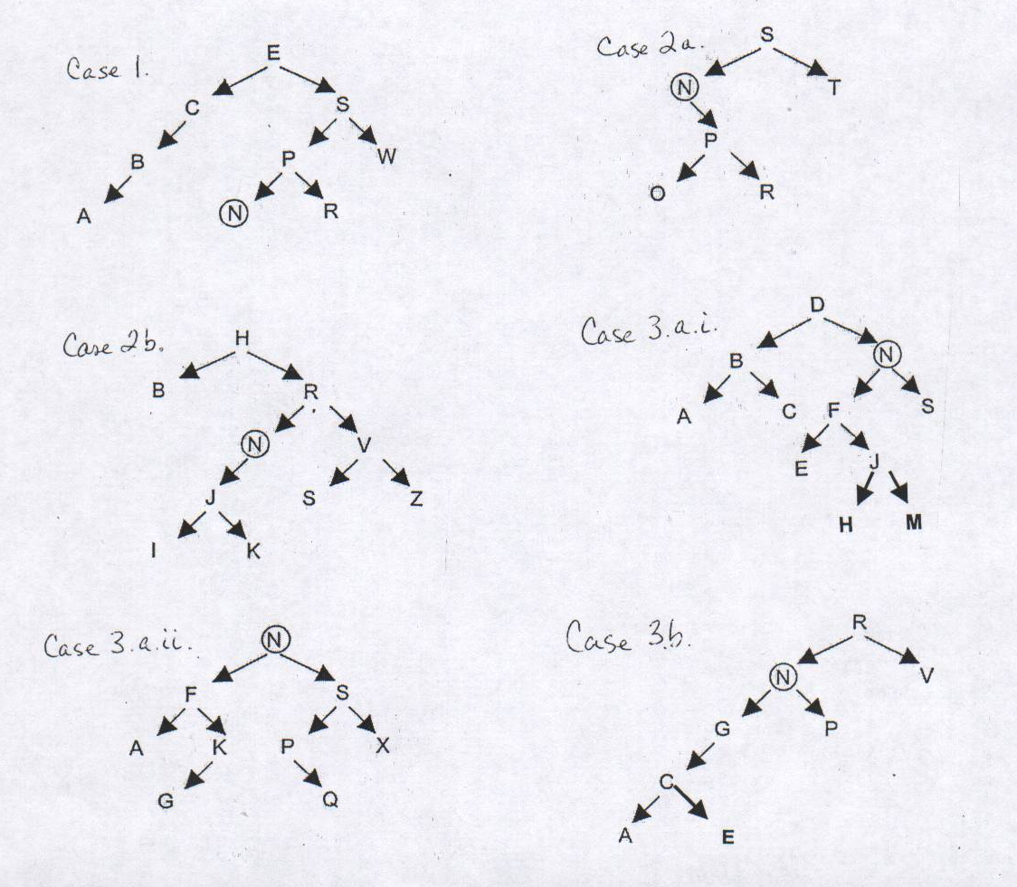

Lambert & Osborne discuss their remove-a-node algorithm on p 736.

One of my students thought it was much easier not to keep track of two pointers. He just kept track of the parent pointer, and every time he needed a child, he used parent.getLeft() or parent.getRight(). He still had to take care of all the cases.
Let’s try it again:
Case 1: if target is a leaf . . .
Case 2 a: if target has one child to right . . .
b: if target has one child to left . . .
Case 3: target has two children.
a: if left child has a right, follow to bottom,
i. if it’s a leaf . . .
ii. if it has a left child . . .
b: if left child only has a left . . .

